# Assignment 6

## Qns. 1a)

The following predictor variables were used in our model construction.

Price~Age_08_04+KM+HP+Automatic+Doors+Quarterly_Tax+Mfr_Guarantee+ Guarantee_Period+Airco+Automatic_airco+CD_Player+Powered_Windows+Sport_Model+

+Tow_Bar+ToyotaDF_CNG+ToyotaDF_Diesel+ToyotaDF_Petrol

Change in RMS Error with respect to varying threshold rate.

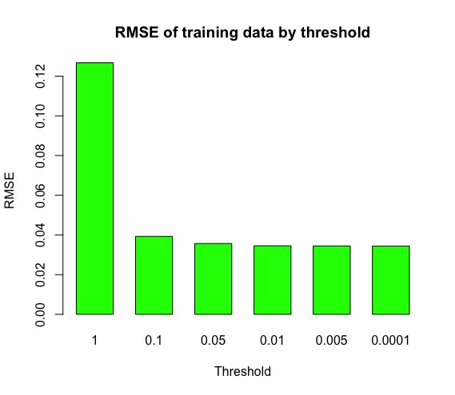

We can observe that changing the threshold beyond 0.01 brings us minuscule improvements in error.

## Qns. 1b)

Likewise, when we run the same script for our validation data, we get,

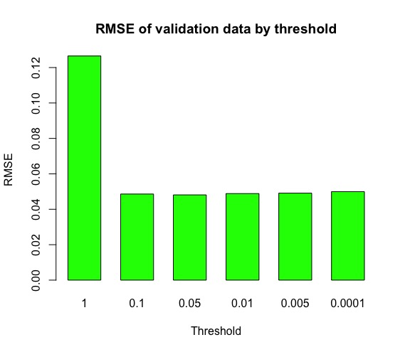

This seems to suggest that changing our threshold beyond 0.05 provides very less increase in performance.

## Qns. 1c)

On changing the number of hidden layer nodes in our neural network,

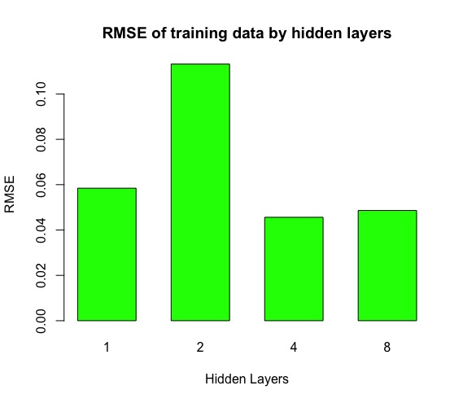

Our RMS Error increased for 2 hidden layer nodes and was the least for 4 hidden layer nodes

## Qns. 1d)

On conducting the same experiment for 2 hidden layers,

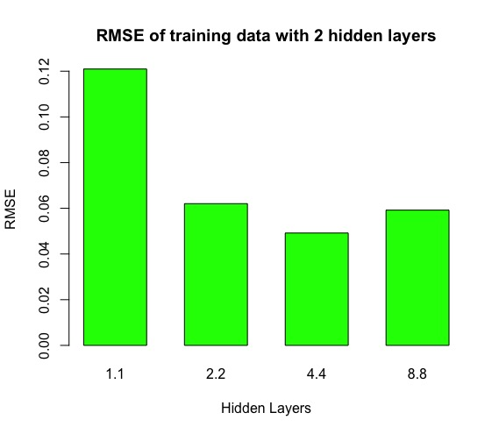

We observed the least RMS error at 4 layer nodes on two levels.

## Qns. 1e)

Finally, we changed the learning rate and observed the RMS

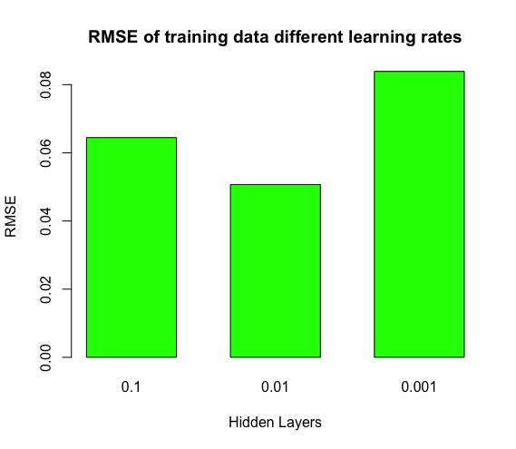

We observed the lowest RMS for a learning rate of 0.01.